# Table of Contents

Contents

Table of Contents 1

Important Links 2

SmartPac 3 wiki 2

SmartPac 5 wiki 2

1.16 - Gripper Adv/Ret Cycle Fault 3

Material Setup 4

Kickout “The scanned box barcode is not valid” 6

HMI not showing data after update 7

ASIN Tote Supply conveyor empty and/or Machine Starved warnings on HMI 8

# Important Links

## SmartPac 3 wiki

* <https://w.amazon.com/index.php/FCShip/SmartPac>

## SmartPac 5 wiki

* <https://w.amazon.com/bin/view/FCShip/SmartPac/Version5_x/>

# 1.16 - Gripper Adv/Ret Cycle Fault

* Indicates the gripper advance (move to right) cylinder advance reed switch is not working
* It is suggested that this sensor be repaired
* If you choose not to repair the sensor, enable g_par.24

# Material Setup

Only the config for the material you are running should be active (ON). Typically, this is g_par_FilmWidth30in as shown in the screen shot below

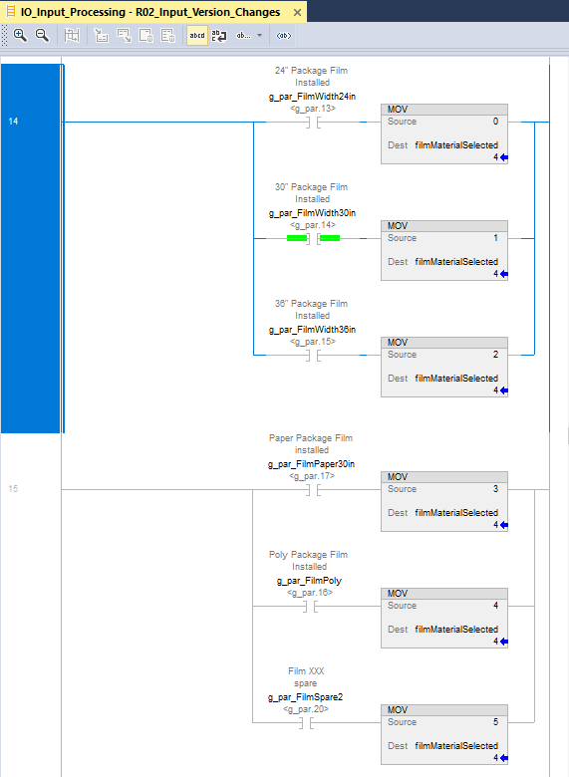

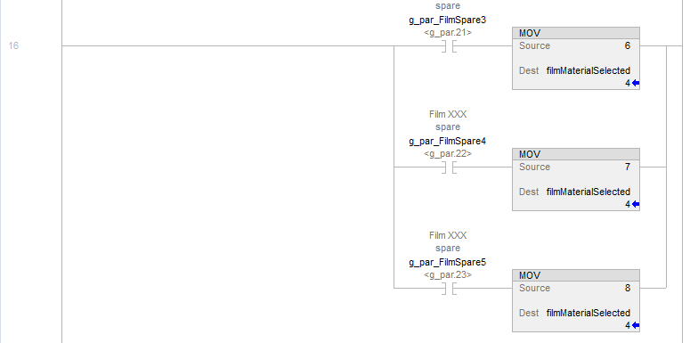

# Kickout “The scanned box barcode is not valid”

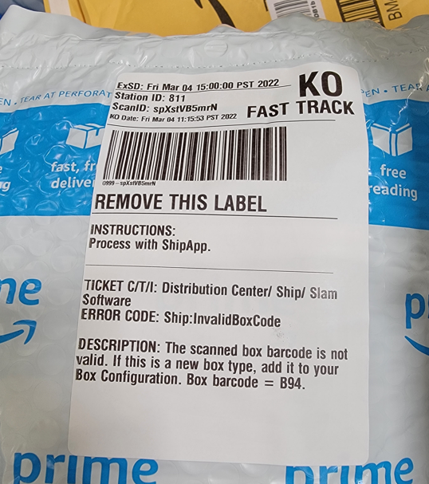

# HMI not showing data after update

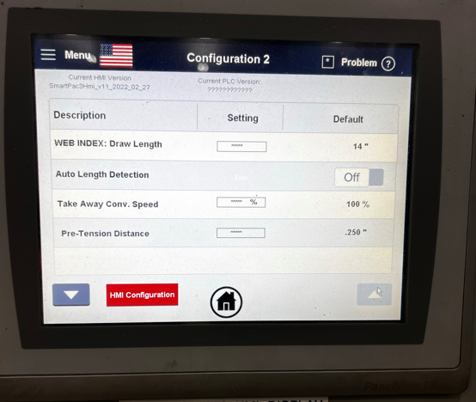

Update HMI firmware

<https://drive.corp.amazon.com/folders/SmartPac/Code%20Repository/02_HMI%20Code/SmartPac%203.x/firmware>

# ASIN Tote Supply conveyor empty and/or Machine Starved warnings on HMI

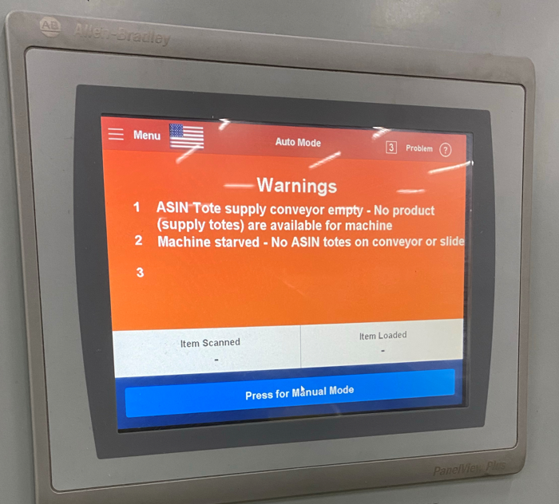

This is likely due to sensors being light activated vs dark activated.

* gPar.7 and gPar.8 allow inverting the sensor if needed. <https://w.amazon.com/index.php/FCShip/SmartPac#g_Par_Definitions_.28Machine_Option_Settings.29>
* Setup Information

<https://w.amazon.com/index.php/FCShip/SmartPac#OEE_Starved_Condition_Definition>